- \Operation\Checkweigher\Checkweigher
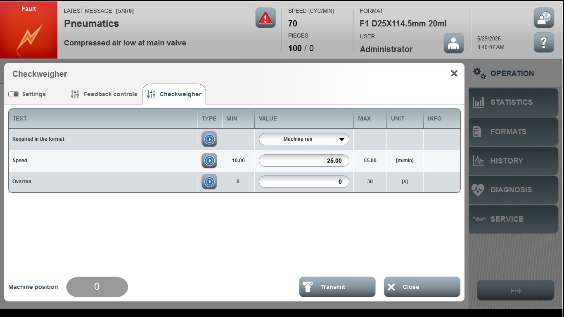
Acceptance criterion | Limits | Pass / Fail: Dev-No. | Date | Initials
Screen matches screenshot | N / A
Speed | 10.00...55.00
Overrun | 0 … 30

